SIMATS ENGINEERING
ASSESSMENT TOOL 1
COURSE NAME: Database Management Systems
COURSE CODE: CSA05

COURSE OUTCOME COVERED

CO2: Apply the relational model, relational algebra, SQL query structures, and views to solve database querying and data manipulation problems. (BL3, BL6)

Activity Tool : Analytical Problem Solving (High)
Assessment Tool Weightage: 40%

QUESTIONS
Q.No | Question | Bloom's Level
1 | Given a set of relations and sample data, write SQL queries to retrieve specific information using joins and subqueries, and explain the logic used. Bloom’s Level: BL3 – Apply | BL4 – Analyze
2 | Using relational algebra, formulate expressions to solve complex queries such as retrieving records that satisfy multiple conditions across relations.  Bloom’s Level: BL4 – Analyse | BL5 – Evaluate
3 | Given a real-world scenario (e.g., banking or student system), design a relational schema and construct appropriate SQL queries for data retrieval and updates. Bloom’s Level: BL6 – Create | BL6 – Create
4 | Analyse a given SQL query with nested subqueries and predict its output, explaining each step of execution. Bloom’s Level: BL4 – Analyze | BL6 – Create
5 | Compare different SQL approaches (joins vs subqueries) for solving the same problem and evaluate their efficiency. Bloom’s Level: BL5 – Evaluate | BL4 – Analyze
6 | Design and implement views for a database system to provide restricted data access, and justify their use for security and abstraction.  Bloom’s Level: BL6 – Create | BL5 – Evaluate
7 | Given a database schema, write relational algebra expressions and convert them into equivalent SQL queries, analyzing differences in representation.  Bloom’s Level: BL4 – Analyze | BL4 – Analyze
8 | Optimize a set of inefficient SQL queries by restructuring them using joins, indexing concepts, or views, and evaluate performance improvements.  Bloom’s Level: BL5 – Evaluate | BL5 – Evaluate
9 | Develop a complex SQL query involving grouping, aggregation, and nested queries to solve a real-world problem.  Bloom’s Level: BL6 – Create | BL6 – Create
10 | Given multiple relations, analyze the query requirements and decide whether to use views, joins, or subqueries, justifying your choice with reasoning.  Bloom’s Level: BL5 – Evaluate | BL5 – Evaluate

Code of Conduct:

I Darshinie Karani.V.M (192520033) (Name / Reg No) certify that this submission is my original work and that I have adhered to the guidelines specified for this assessment.
I understand that any violation of academic integrity rules will result in disciplinary action.

Signature of the student:

ANSWERS

1. 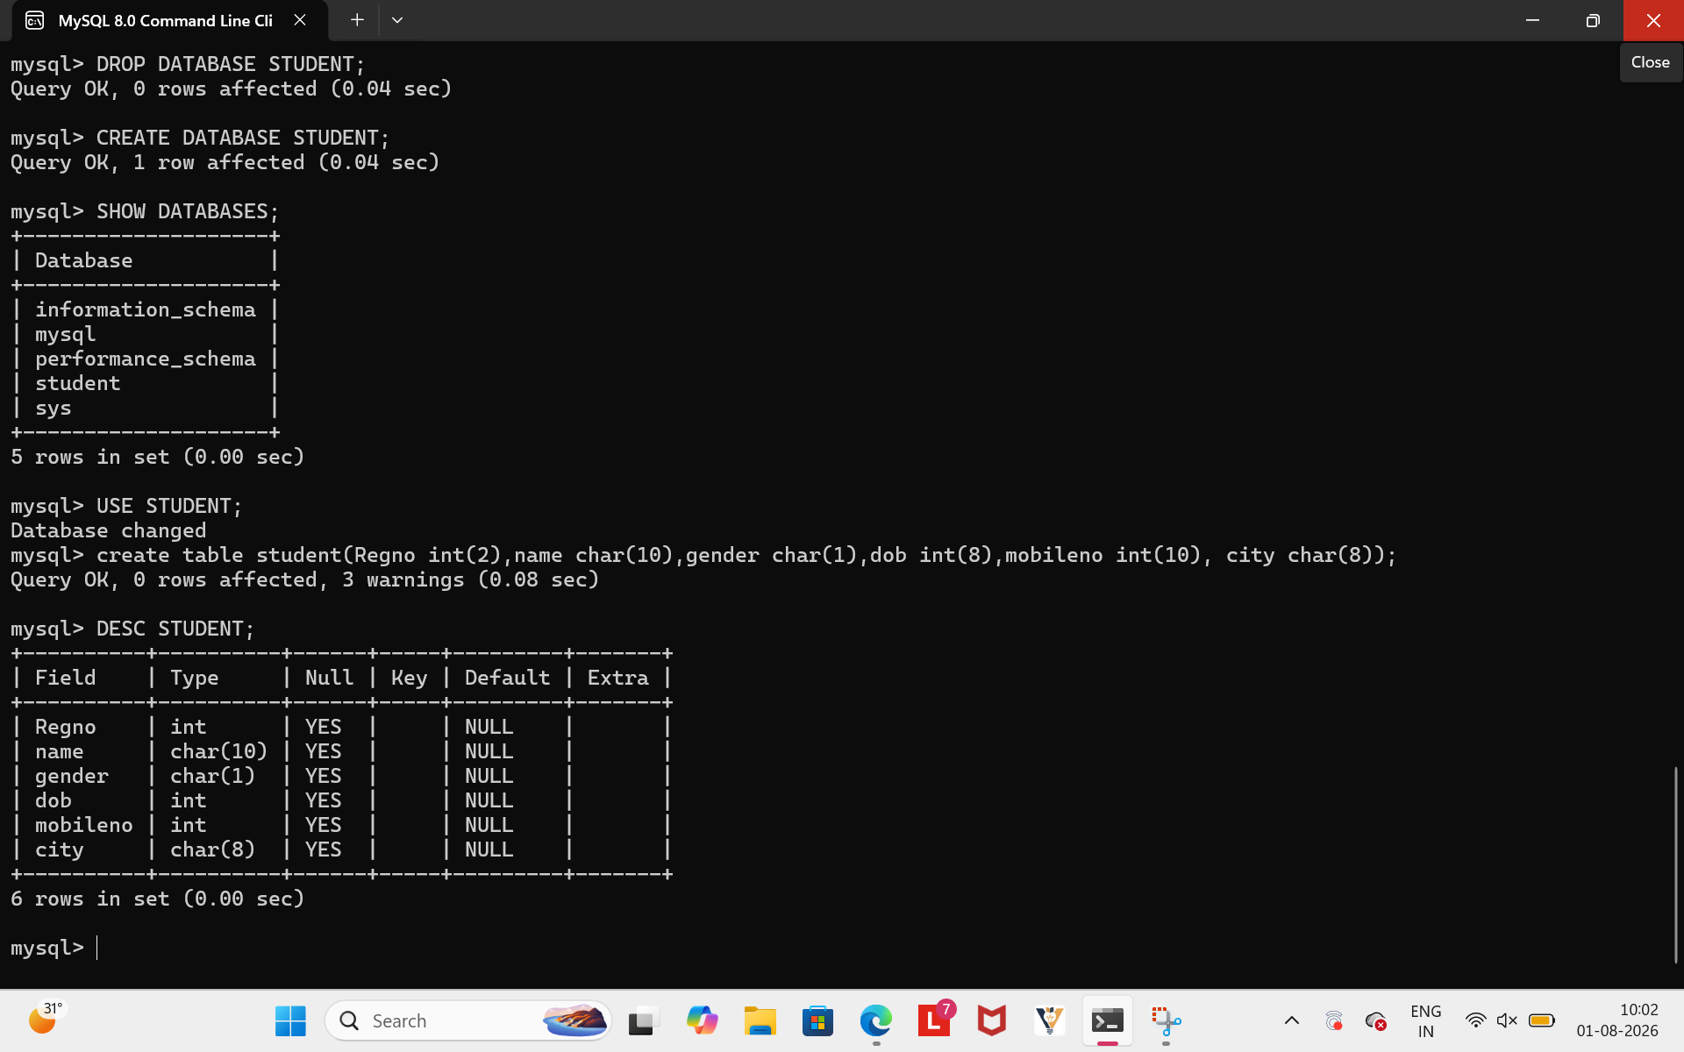

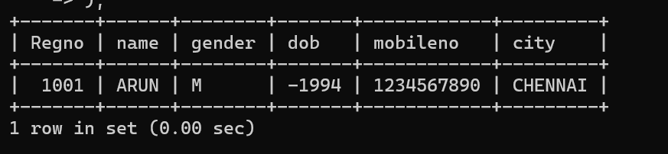
LOGIC:The subquery finds Arun's city, and the outer query displays all students from that city.

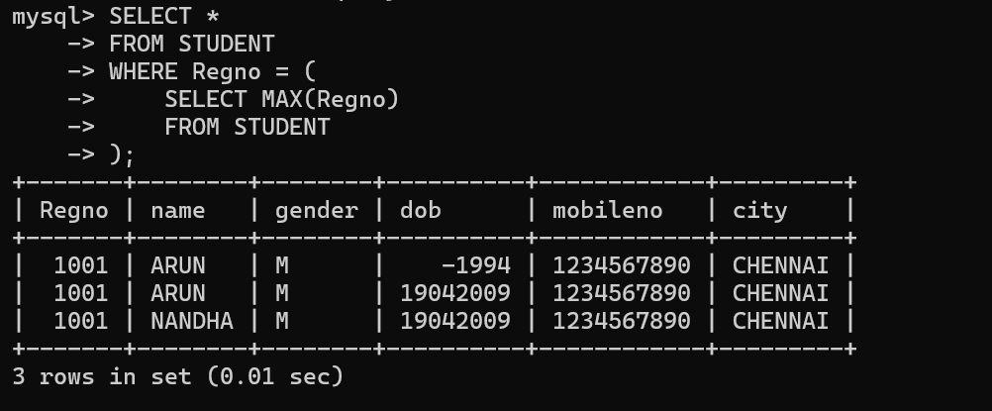
Logic: The subquery finds the highest registration number, and the outer query retrieves that student's details.

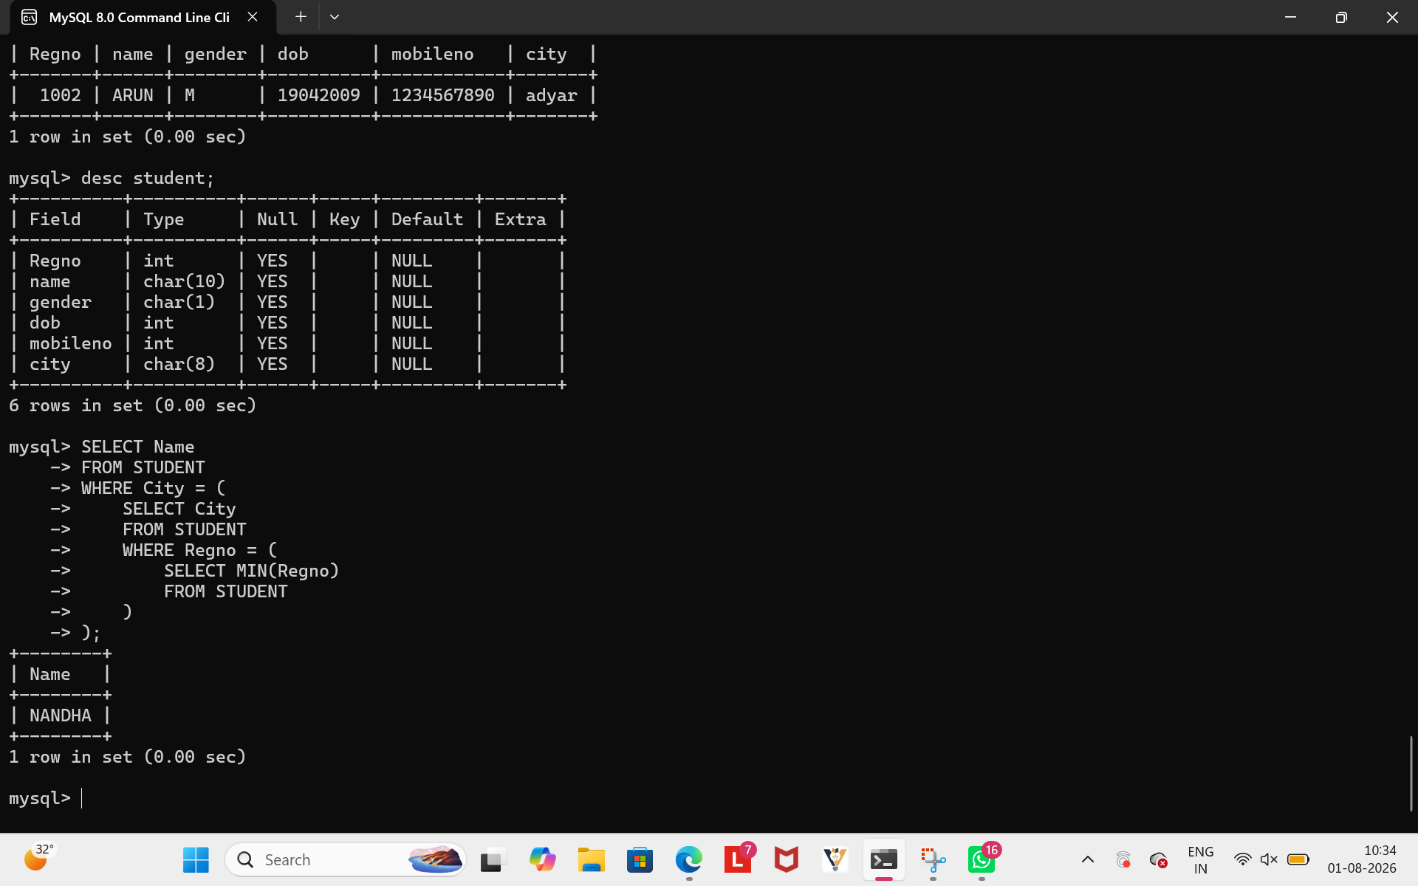
Logic:The inner subquery finds the first registration number, the next subquery gets that student's city, and the outer query lists all students from that city.

2.
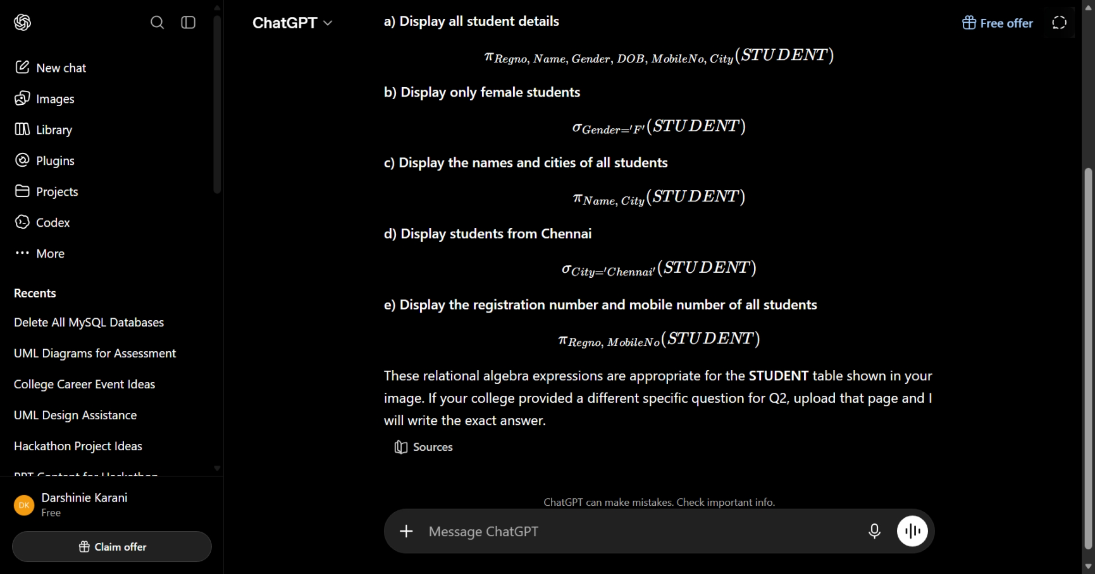

3. 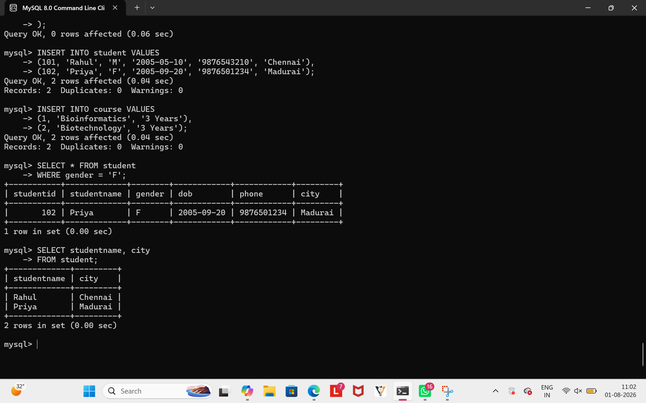

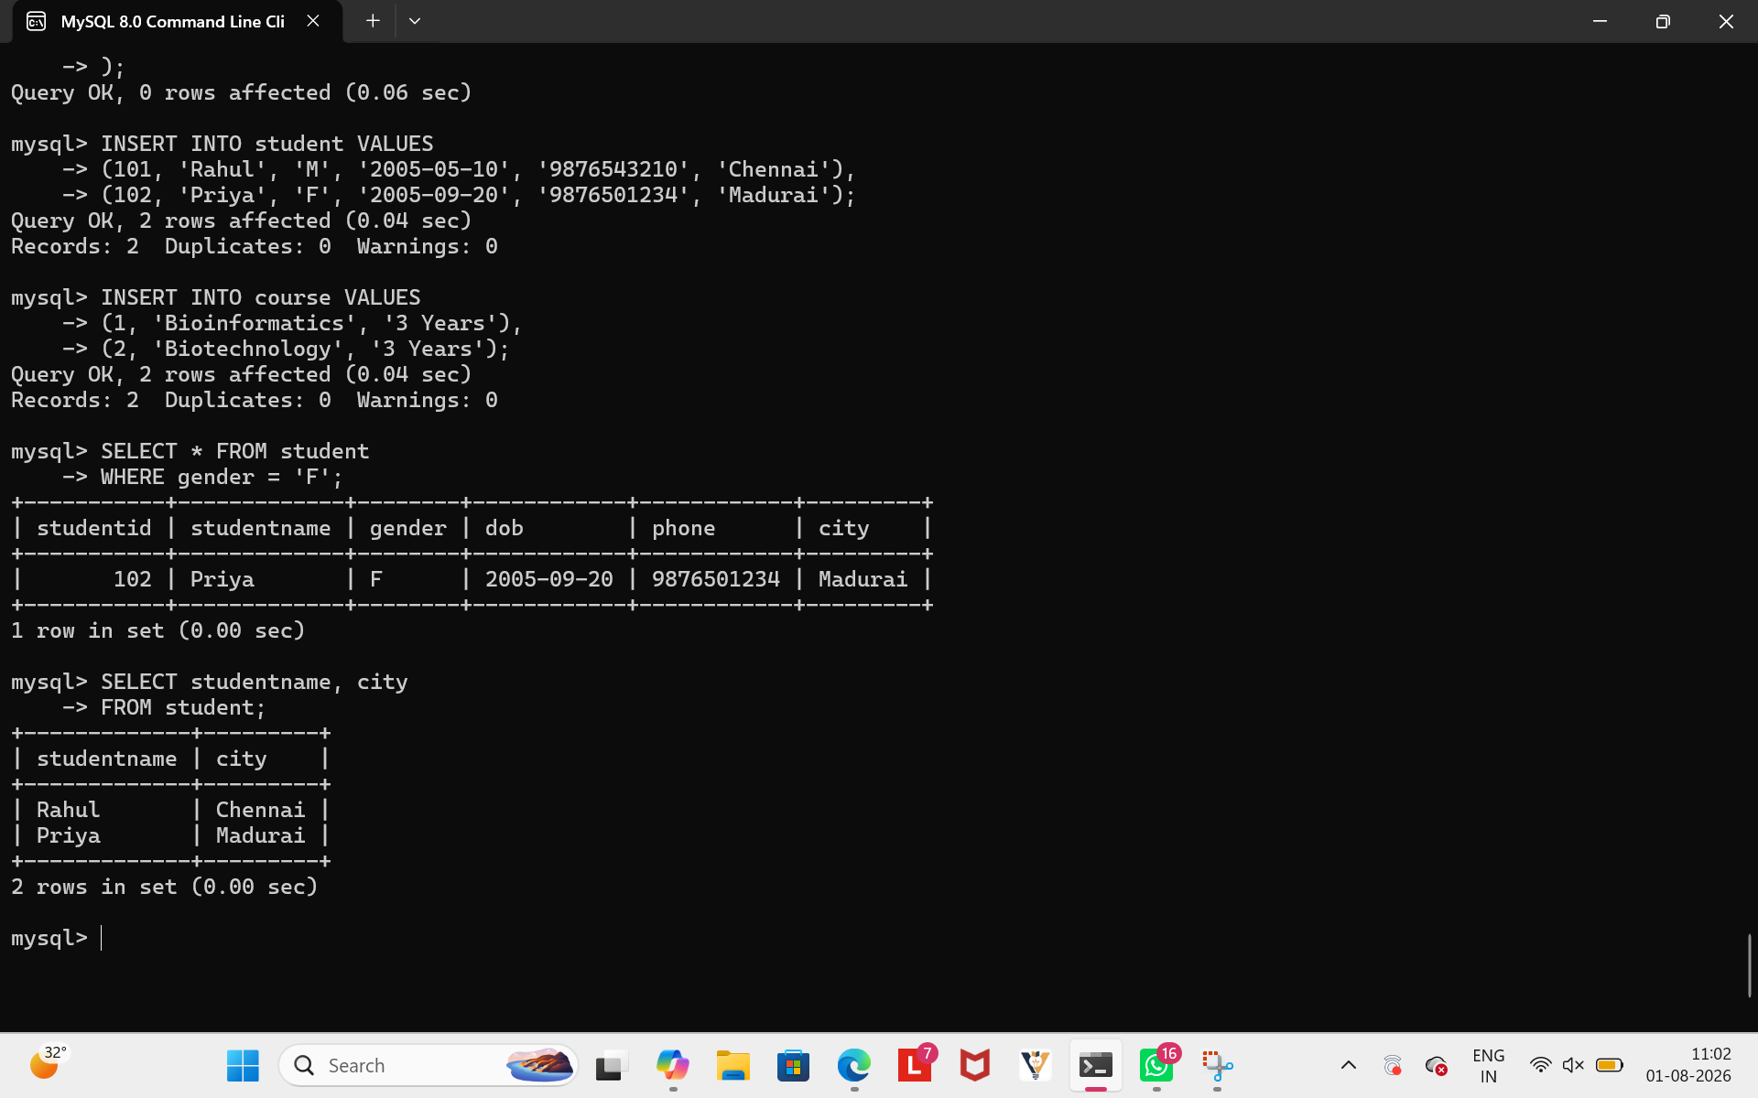
This is a complete Student Management System design with a proper relational schema, CREATE TABLE statements, and SQL queries for data retrieval and updates, suitable for a DBMS assignment or exam.
4.
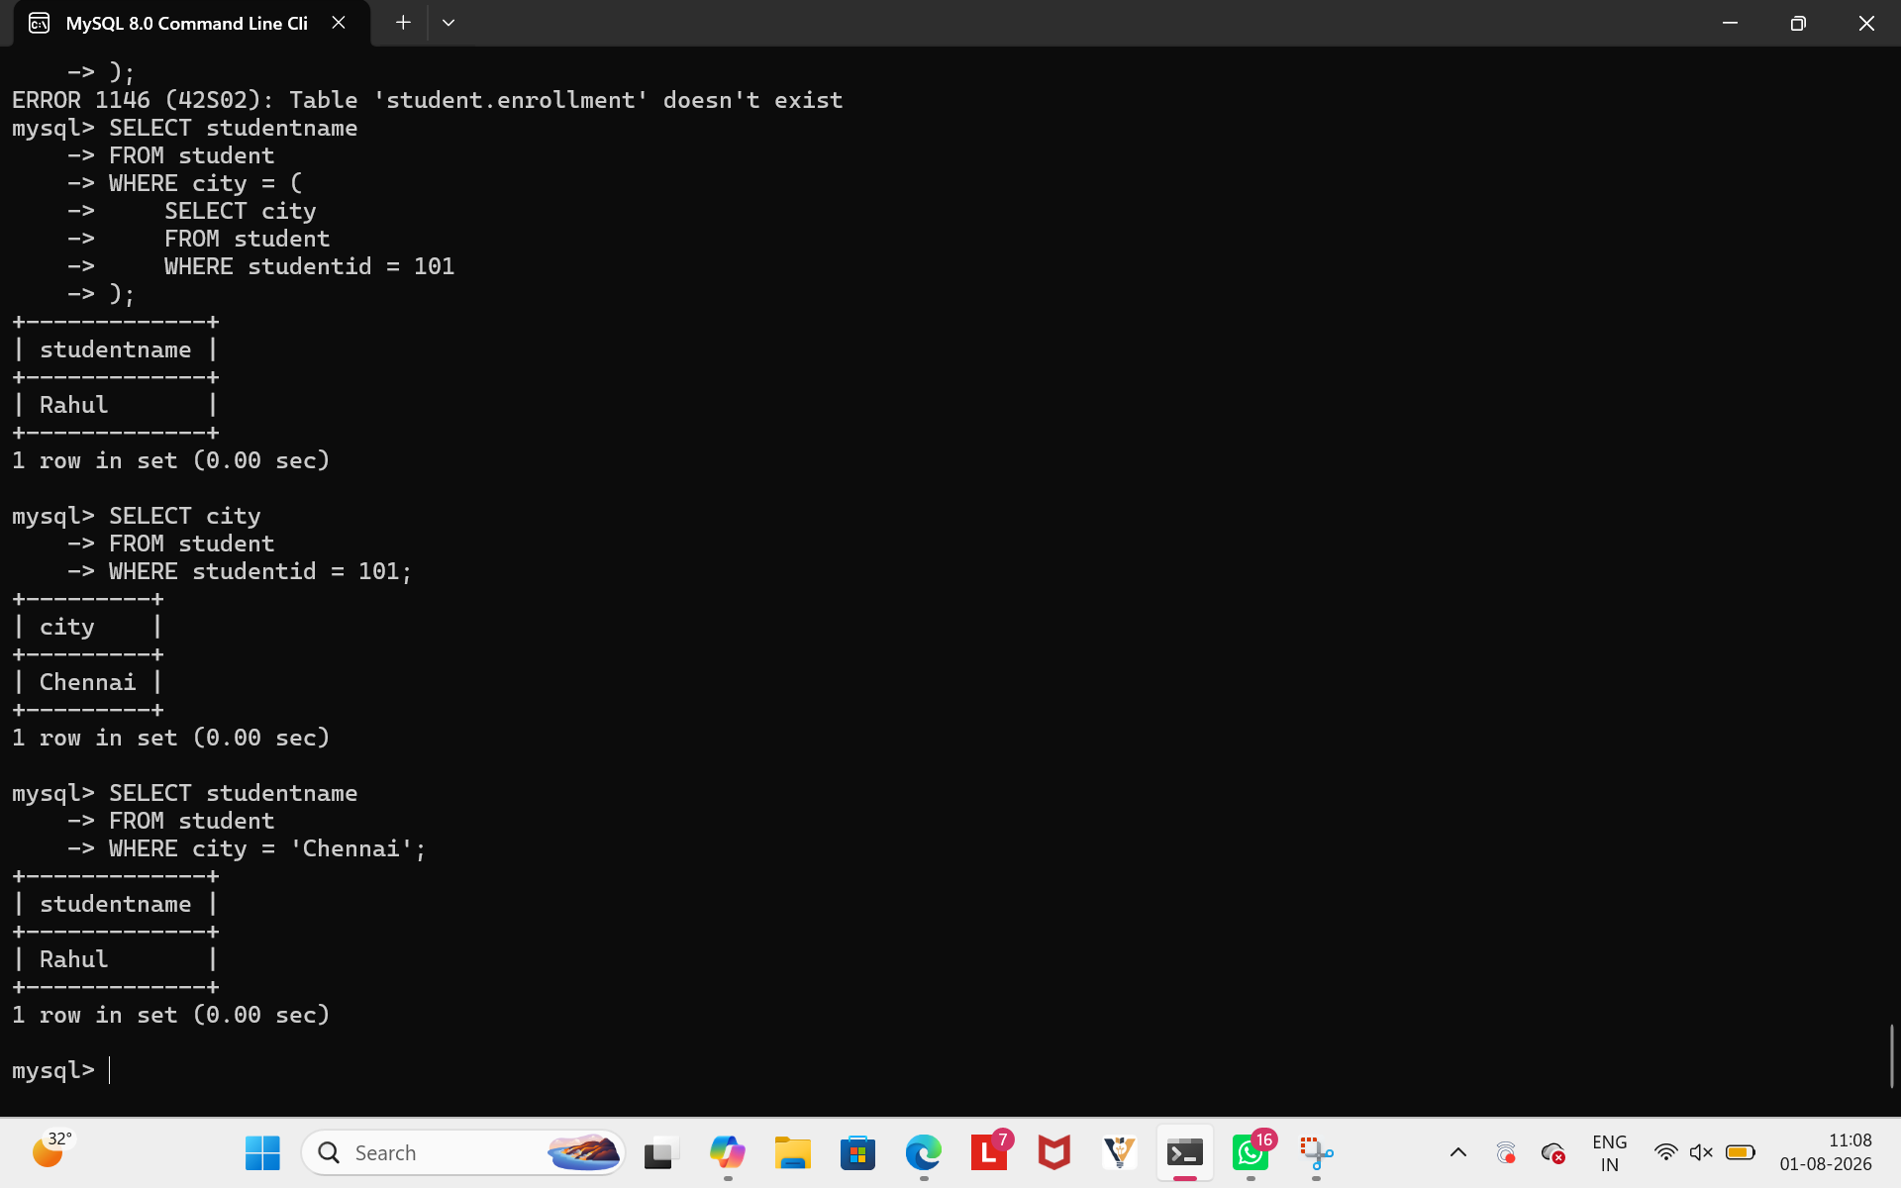

Explanation:
The inner subquery finds the city of the student with StudentID = 101, which is Chennai.
The outer query retrieves the names of all students whose city is Chennai.
Therefore, the output is Rahul.

5.
Table of the student
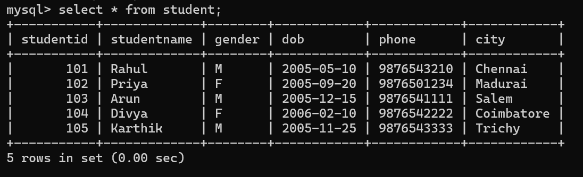

Joins
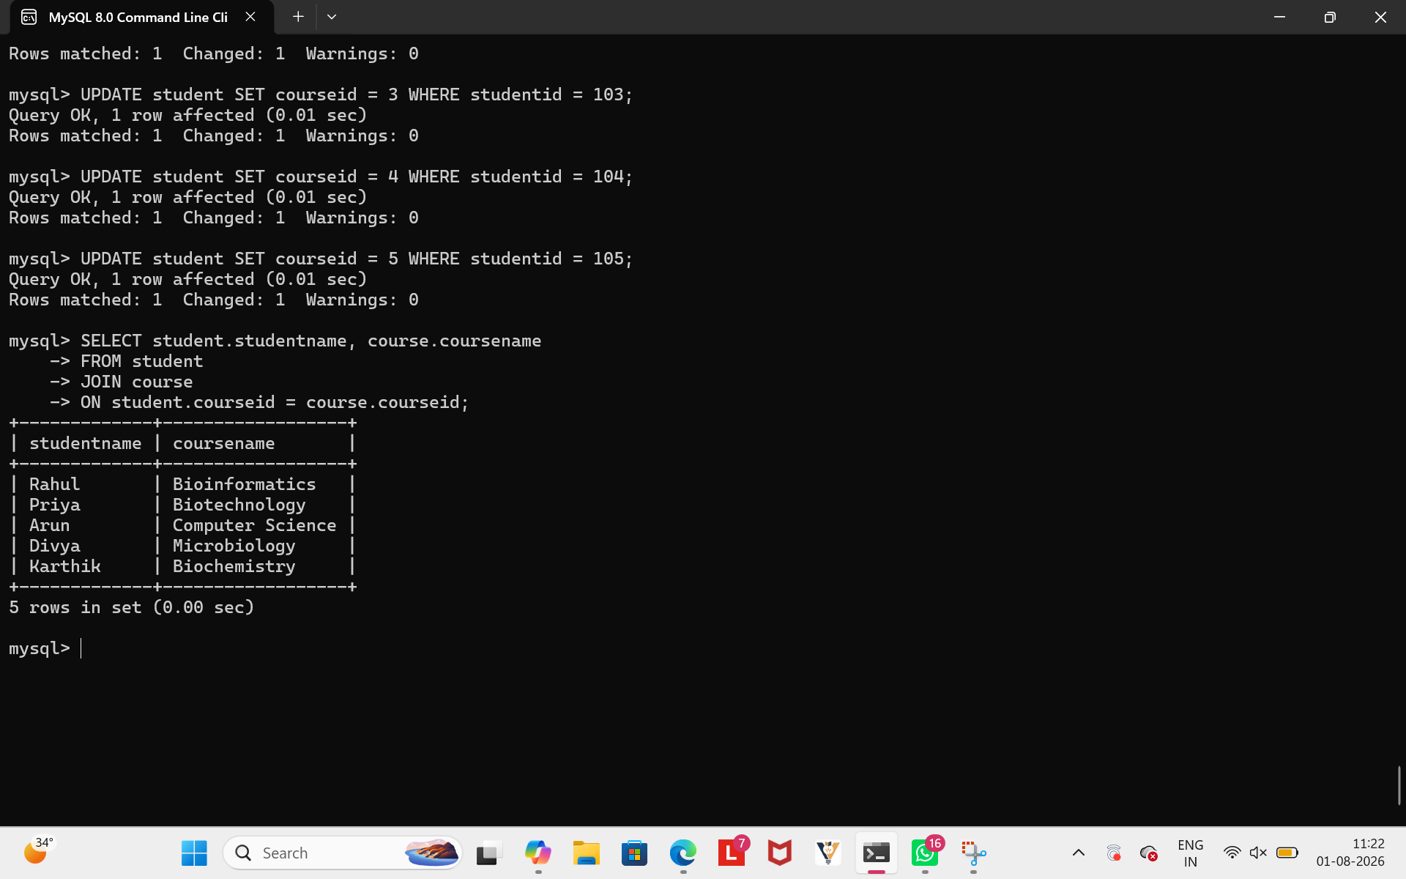

Subquery
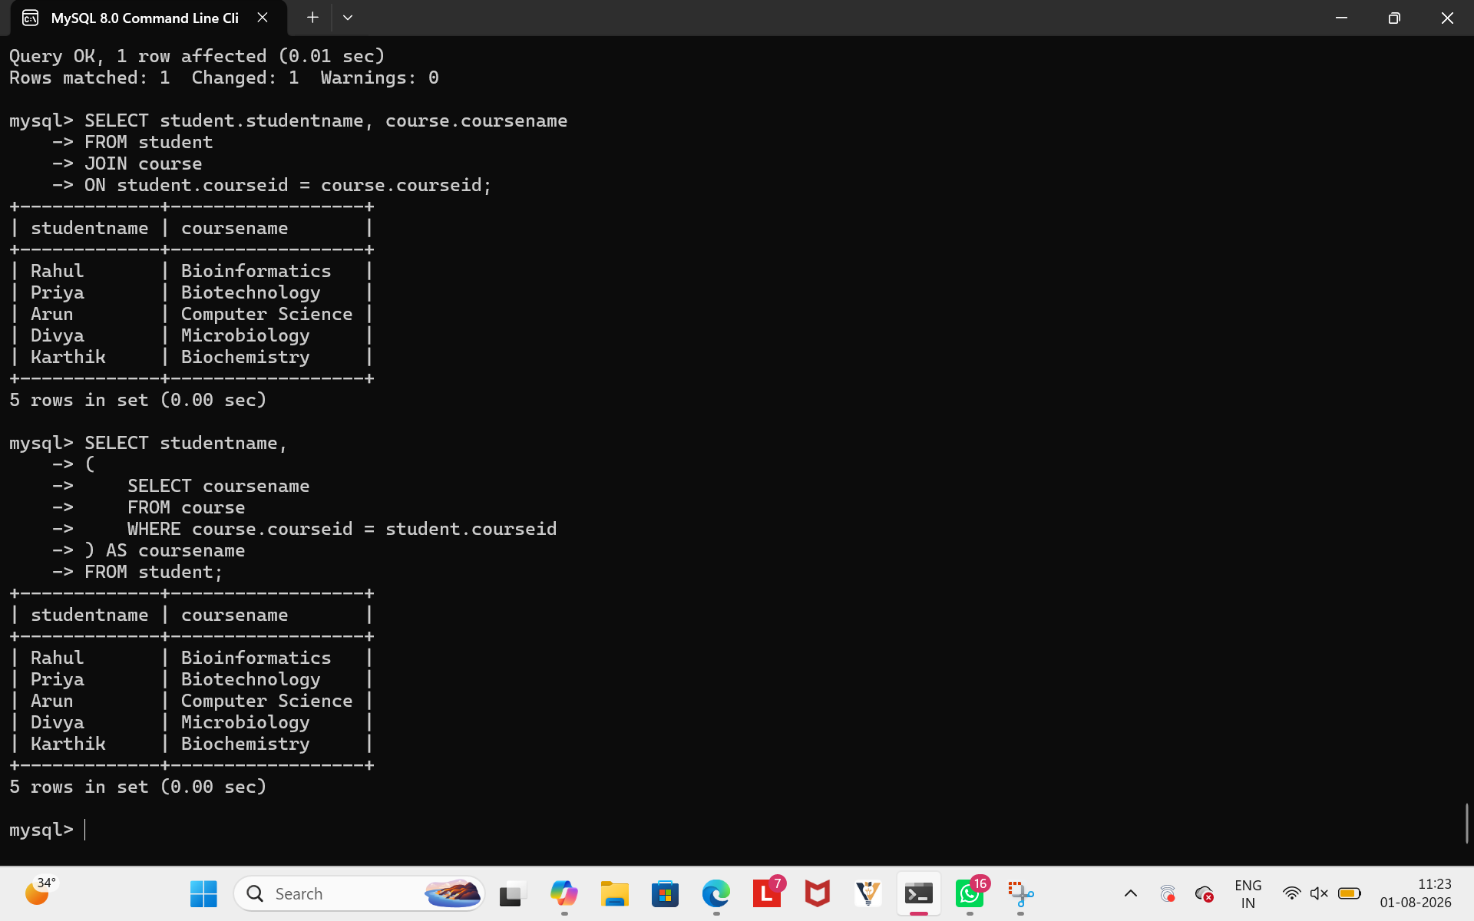

JOIN | Subquery
Combines data from multiple tables using a common column. | Uses an inner query to retrieve related data.
Faster and more efficient for large datasets. | May be slower because the subquery can execute repeatedly.
Easier to use when retrieving related records from multiple tables. | Useful for simple lookups and filtering.
Preferred in real-world database applications. | Suitable for simple queries with fewer records.

Evaluation
- Both queries produce the same output.
- JOIN is generally more efficient because it retrieves data from multiple tables in a single operation.
- Subqueries are easier to understand for simple problems but may reduce performance on large databases.
- Therefore, JOIN is the preferred approach for retrieving related data efficiently.
6.
Create a View
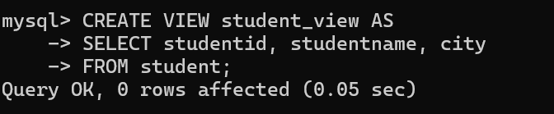
Retrieve Data from the View 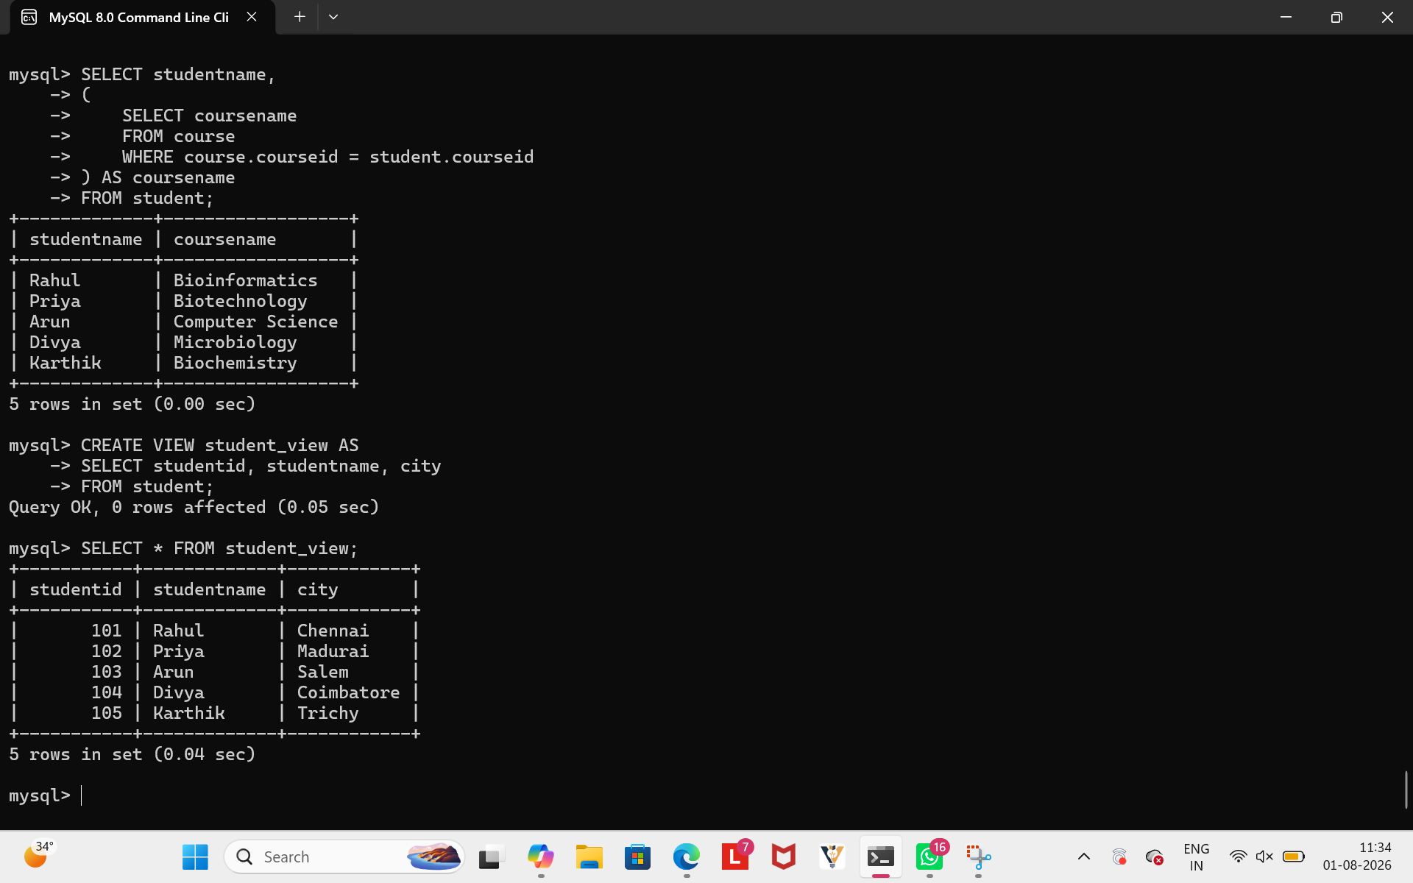

Justification
- A View is a virtual table created from one or more database tables.
- It restricts access to sensitive data by displaying only selected columns.
- It improves security by hiding confidential information such as phone numbers and dates of birth.
- It provides data abstraction, allowing users to access only the required information without exposing the entire table.
- Views simplify complex queries and make data retrieval easier.
Views help improve security, data abstraction, and ease of access by allowing users to see only the information they are authorized to view.
7. Display the names of all students
Relational Algebra:
πStudentName​(STUDENT)

SQL Query


Display the names of students from Chennai

Relational Algebra
σCity=′Chennai′(STUDENT)\sigma_{City='Chennai'}(STUDENT)σCity=′Chennai′​(STUDENT)

SQL Query
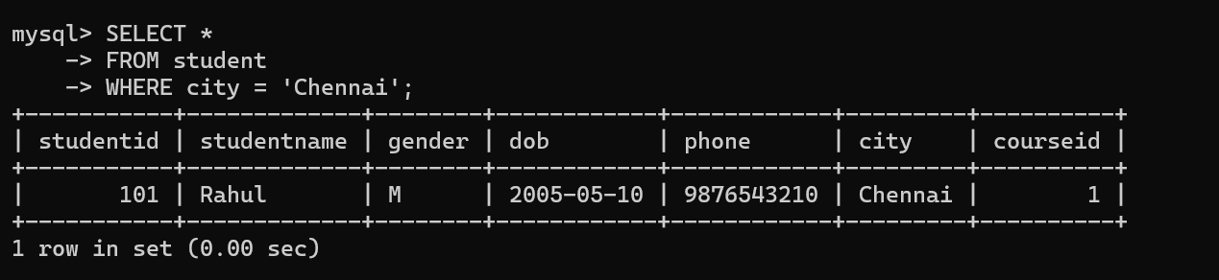

Display student names along with their course names

Relational Algebra
πStudentName,CourseName​(STUDENT⋈STUDENT.CourseID=COURSE.CourseID​COURSE)

SQL Query
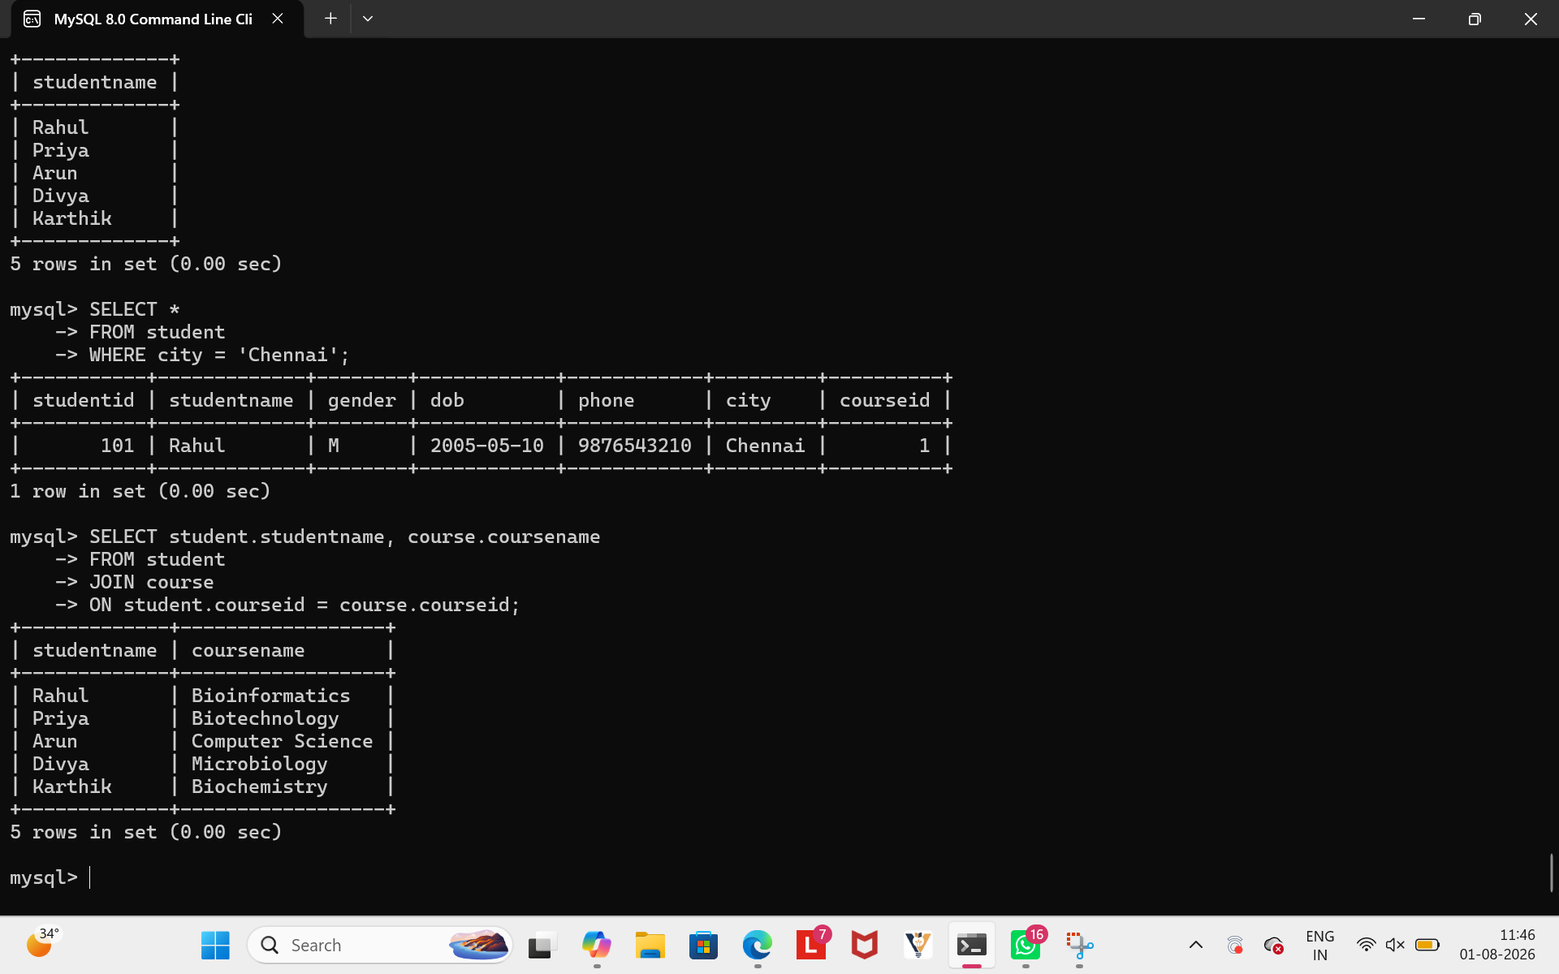

Relational Algebra | SQL
A theoretical query language. | A practical database language.
Uses symbols such as π (Projection), σ (Selection) and ⋈ (Join). | Uses keywords like SELECT, FROM, WHERE, and JOIN.
Describes what data is required mathematically. | Specifies how to retrieve the data from the database.
Mainly used for database design and query optimization. | Used to create, retrieve, update, and manage data in DBMS.

- Relational Algebra provides the mathematical foundation for database queries.
- SQL is the practical implementation of relational algebra used in real-world database systems.
- Both produce the same results, but SQL is easier to write and execute in a DBMS.

8.
Inefficient SQL Query USING SUBQUERY
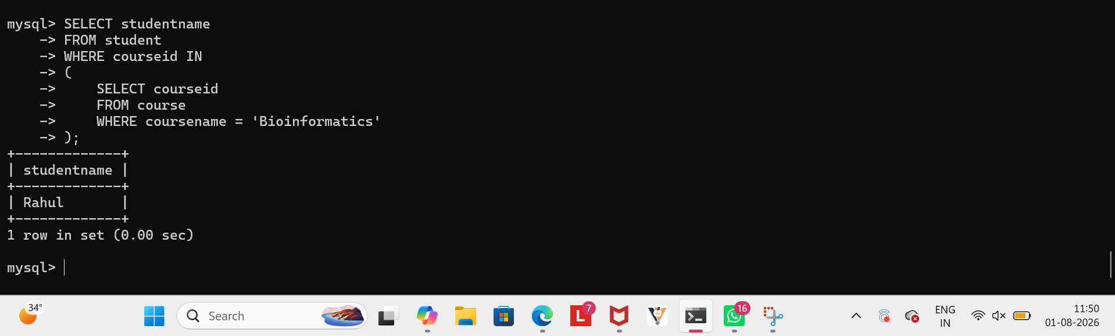

Optimized SQL Query USING JOIN
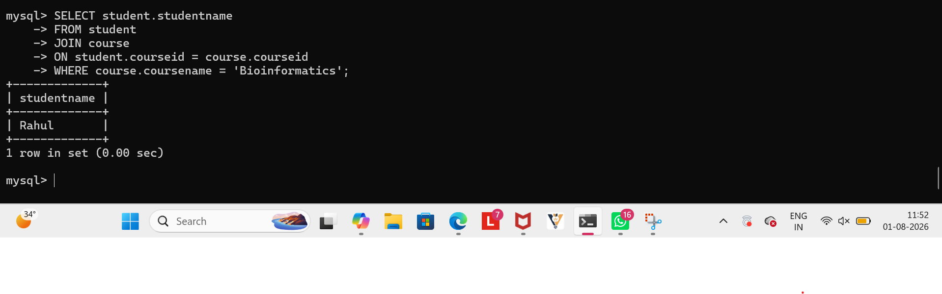
Using an Index

Using a View
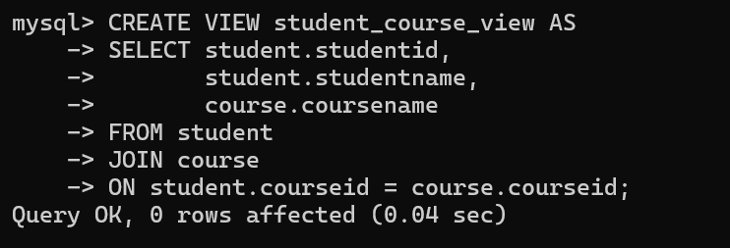

Retrieve data from the view:
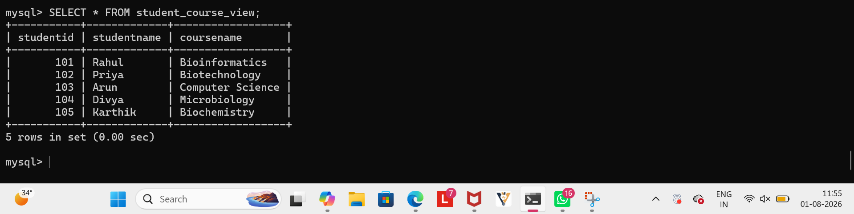

Before Optimization | After Optimization
Used a subquery. | Uses a JOIN.
Slower for large datasets. | Faster and more efficient.
No index on courseid. | Index improves search and join performance.
Query written repeatedly. | View simplifies data retrieval.

EVALUATION:
- Replacing subqueries with JOINs improves execution speed.
- Creating an index on frequently searched columns reduces query execution time.
- Using a view simplifies complex queries and improves data abstraction.
- These optimizations enhance the overall performance and efficiency of the database system.

9.
SQL Query
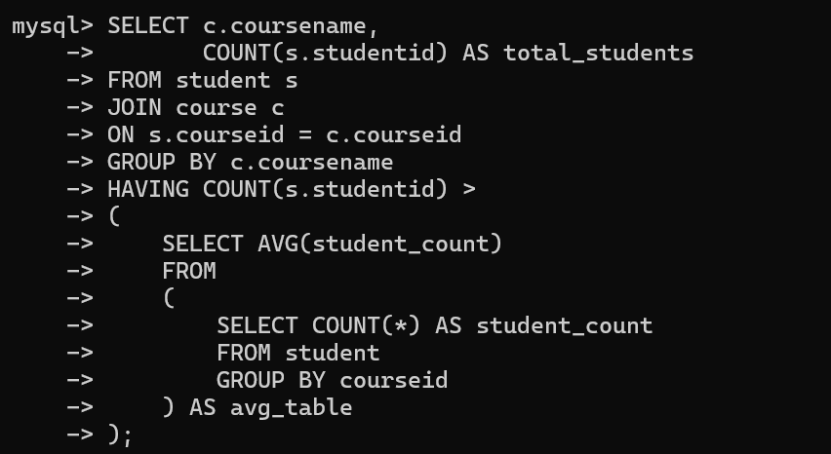
Output


JOIN combines the student and course tables using courseid.

COUNT(studentid) counts the number of students in each course.

GROUP BY groups the students according to their course.

The nested query calculates the average number of students enrolled per course.

The HAVING clause displays only those courses whose student count is greater than the average.

Real-World Application
This query helps educational institutions identify popular courses with higher-than-average enrollment. Such information can be used for faculty allocation, classroom planning, and resource management.
10.
Using JOIN
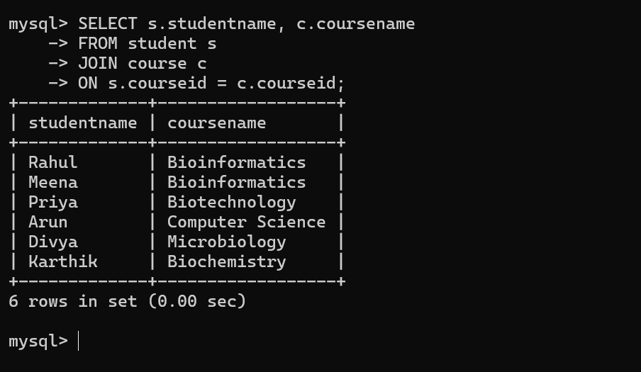
Using a View
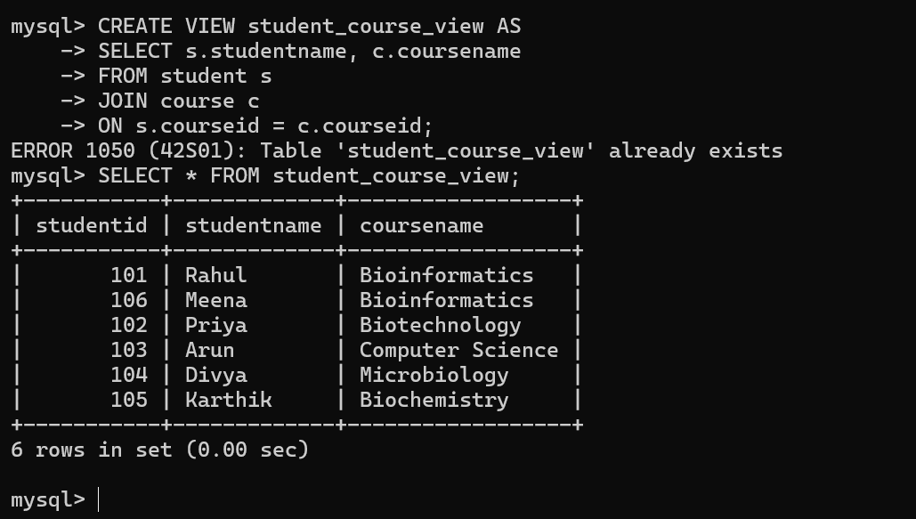

Using a SubQuery

A Subquery is suitable for simple lookups. However, for large databases it may execute repeatedly and can be slower than a JOIN.

Method | Best Use | Advantages | Disadvantages
JOIN | Combining related tables | Fast, efficient, retrieves data in one query | Slightly more complex for beginners
VIEW | Frequently used queries | Improves security, abstraction, and reusability | Depends on the underlying tables
Subquery | Simple lookups | Easy to understand | May be slower on large datasets

Justification
For this Student Management System, JOIN is the most appropriate choice because the required data comes from two related tables (student and course). It is more efficient than a subquery for retrieving related records. A View is useful if the same JOIN query needs to be executed repeatedly or if restricted access to the data is required.
Conclusion
JOIN is the preferred approach for this requirement because it provides better performance and efficiently combines data from multiple relations.

